BORDER DEFENCE AND SURVEILLANCE

A PROJECT REPORT
Submitted by

PATEL BINIT UMESHKUMAR
230143107014
In partial fulfilment for the award of the degree of

BACHELOR OF ENGINEERING
in
Computer Engineering


GOVERNMENT ENGINEERING COLLEGE BHARUCH

Gujarat Technological University, Ahmedabad
May, 2026



Government Engineering College Bharuch

Near K J Polytechnic, Old NH-8, Bholav, BHARUCH – 392 002

CERTIFICATE
This is to certify that the project report submitted along with the project entitled BORDER DEFENCE AND SURVEILLANCE has been carried out by PATEL BINIT UMESHKUMAR under my guidance in partial fulfilment for the degree of Bachelor of Engineering in Computer Engineering, 8th Semester of Gujarat Technological University, Ahmedabad during the academic year 2025-26.

Mr. Shreyas Patel Prof. Namrata Shroff
Internal Guide Head of CE Department

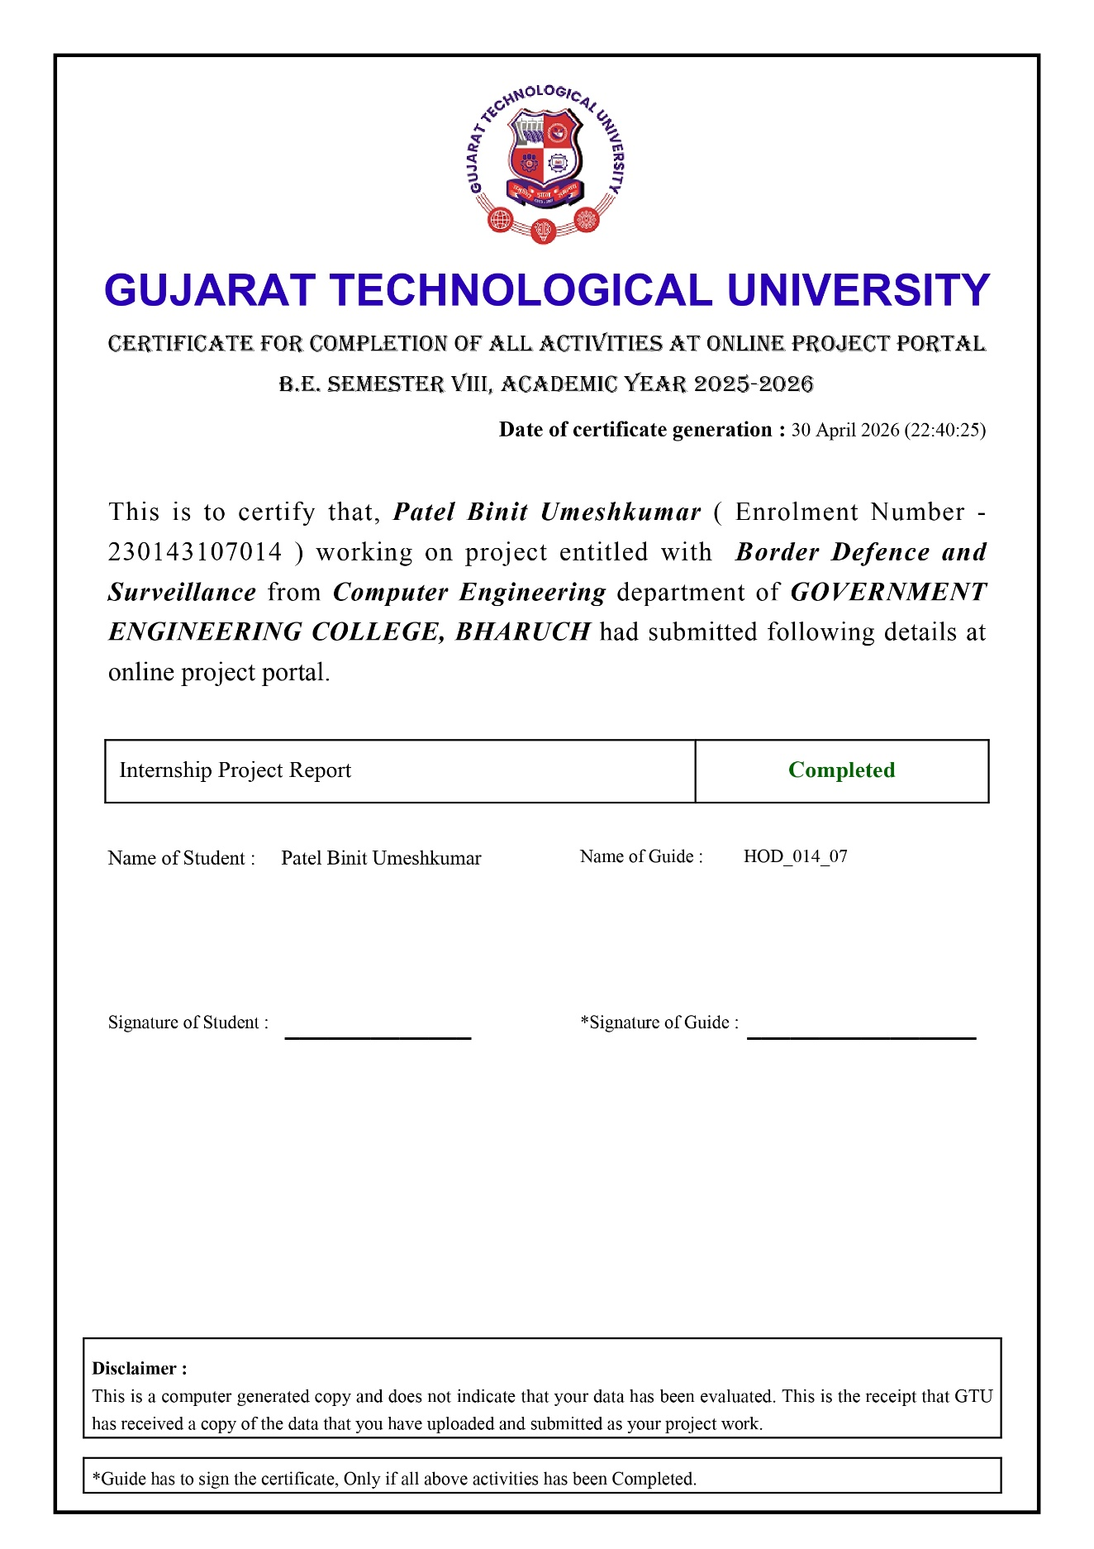




Government Engineering College Bharuch

Near K J Polytechnic, Old NH-8, Bholav, BHARUCH – 392 002

DECLARATION
I hereby declare that the Internship report submitted along with the project entitled "Border Defence and Surveillance " submitted in partial fulfilment for the degree of Bachelor of Engineering in Computer Engineering to Gujarat Technological University, Ahmedabad, is a Bonafide record of original project work carried out by me at Microsoft Elevate Internship Program (via Edunet Foundation and FICE Education) under the supervision of Mr. Shreyas Patel (Internal Guide) and Mr. Adarsh Gupta (External Guide), and that no part of this report has been directly copied from any students' reports or taken from any other source without providing due reference.
I further declare that all information, figures, results, and data presented in this report are accurate and true to the best of my knowledge, and all external sources have been duly acknowledged.

Name of the student Sign of Student
PATEL BINIT UMESHKUMAR ____________

